**1. Consider a case, a folder has multiple files and how would copy it to destination machine path (Try using SCP, cp options in Linux)**

**Cp** is used when both source and destination folders are on the same machine

Cp -r ~/Folder1 ~/Folder2

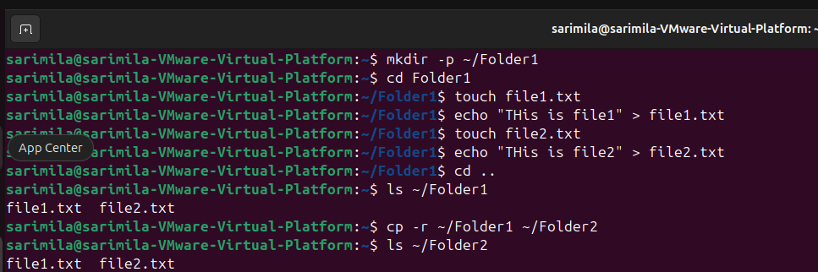

**scp** is used when we want to copy the folder from our VMware machine to another Linux system.

Ensure SSH is Enabled on the Destination. Here ssh status is Active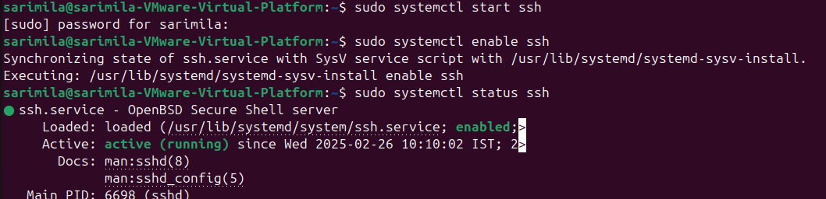

Copy the Folder1 to the Destination(Folder2)

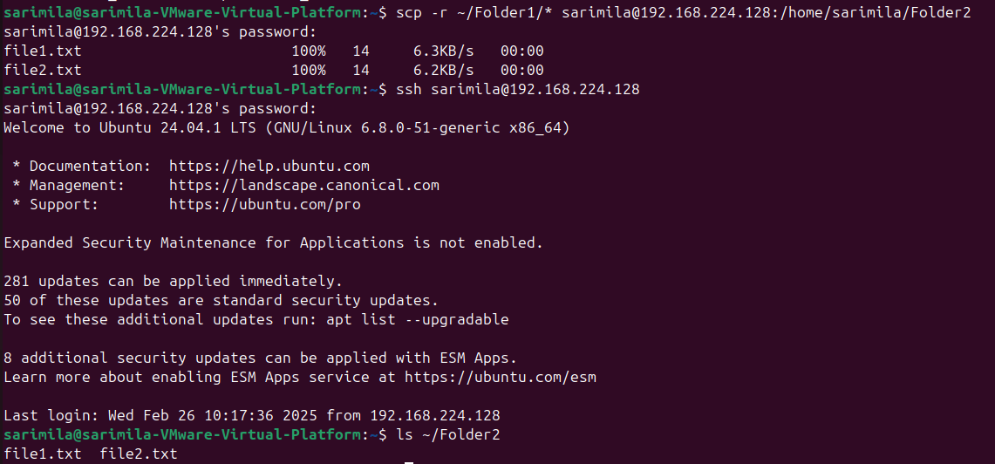scp -r ~/Folder1/* [sarimila@192.168.224.128:/home/sarimila/Folder2](mailto:sarimila@192.168.224.128:/home/sarimila/Folder2)

**2.Host a FTP and SFTP server and try PUT and GET operations.**

**FTP**

sudo apt update && sudo apt install vsftpd -y

sudo systemctl start vsftpd

sudo systemctl enable vsftpd

sudo systemctl status vsftpd

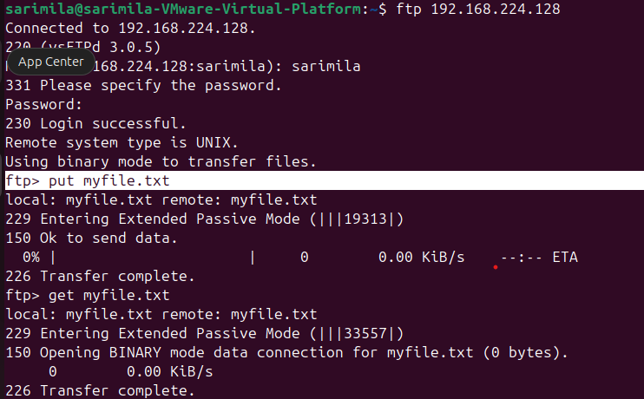

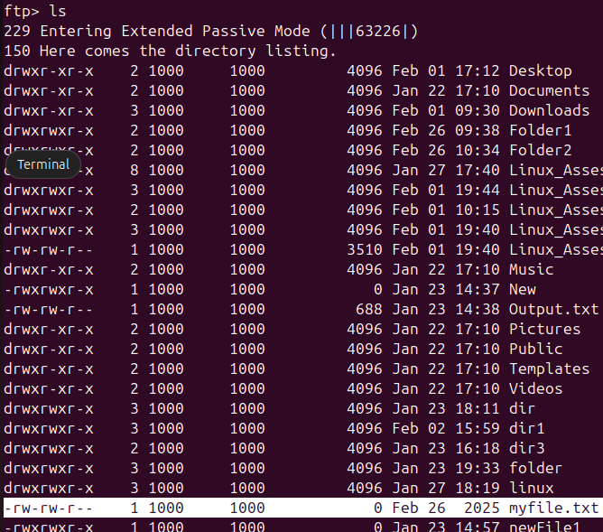

**SFTP**

sudo apt update && sudo apt install openssh-server -y

sudo systemctl status ssh

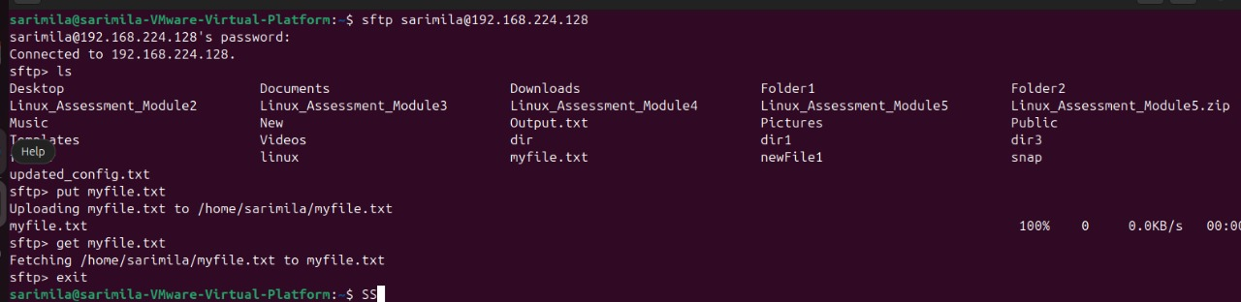

**3. Explore with Wireshark/TCP-dump/cisco packet tracer tools and learn about packets filters.**

Capturing tcp packets

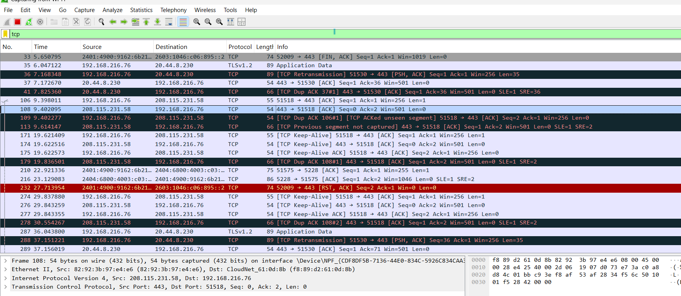

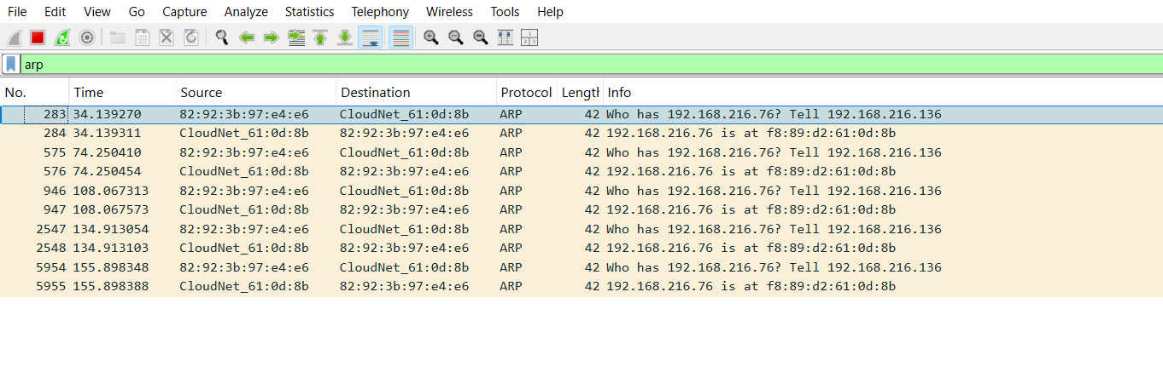Capturing arp packets

tcp.port = = 80 Show only HTTP packets.

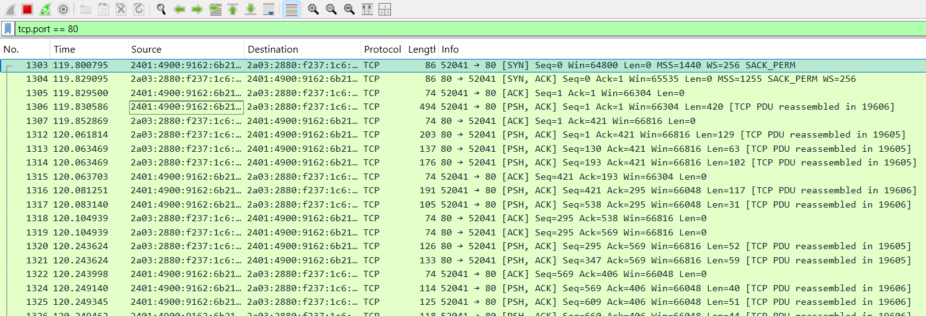

**TCP-dump**

capture all packets on ens33

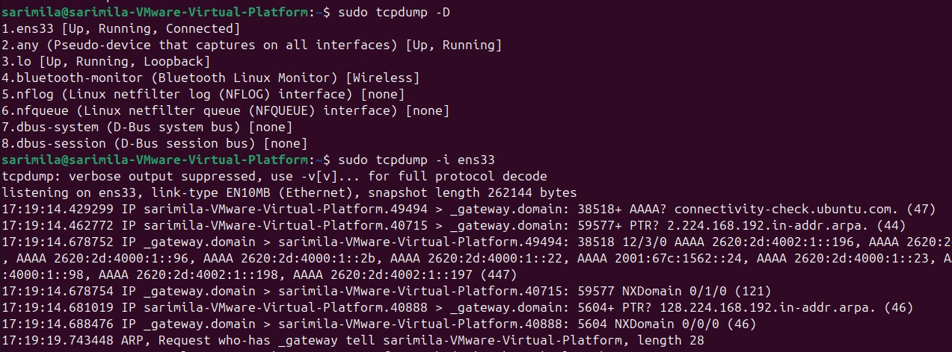

Capture Only TCP Traffic on Port 80 (HTTP)

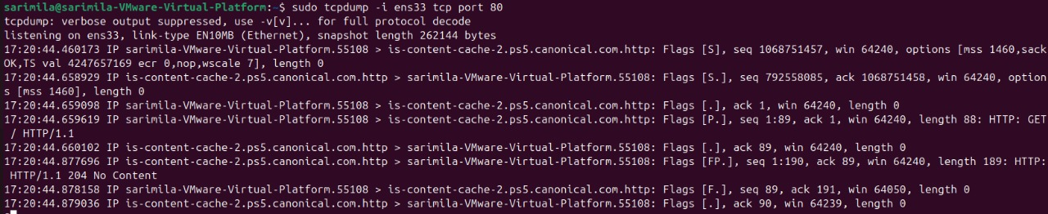

**4. Understand linux utility commands like - ping, arp**

Ping command

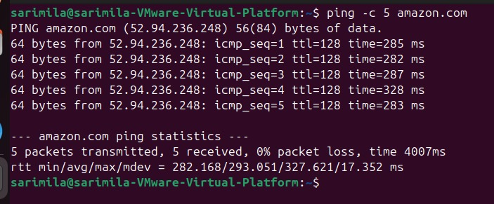

arp & ifconfig command

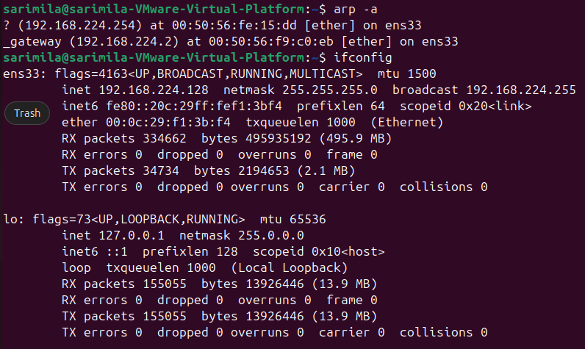

1. **Understand what happens when duplicate IPs configured in a network.**

* Devices with the same IP cannot communicate properly. ARP maps IP addresses to MAC addresses.
* If two devices have the same IP, ARP will randomly assign one MACaddress, causing data to be sent to the wrong machine.
* One or both devices with duplicate IPs will lose network connectivity.

1. **Understand how to access remote system using (VNC viewer, Anydesk, teamviewer and remote desktop connections)**

Using Anydesk

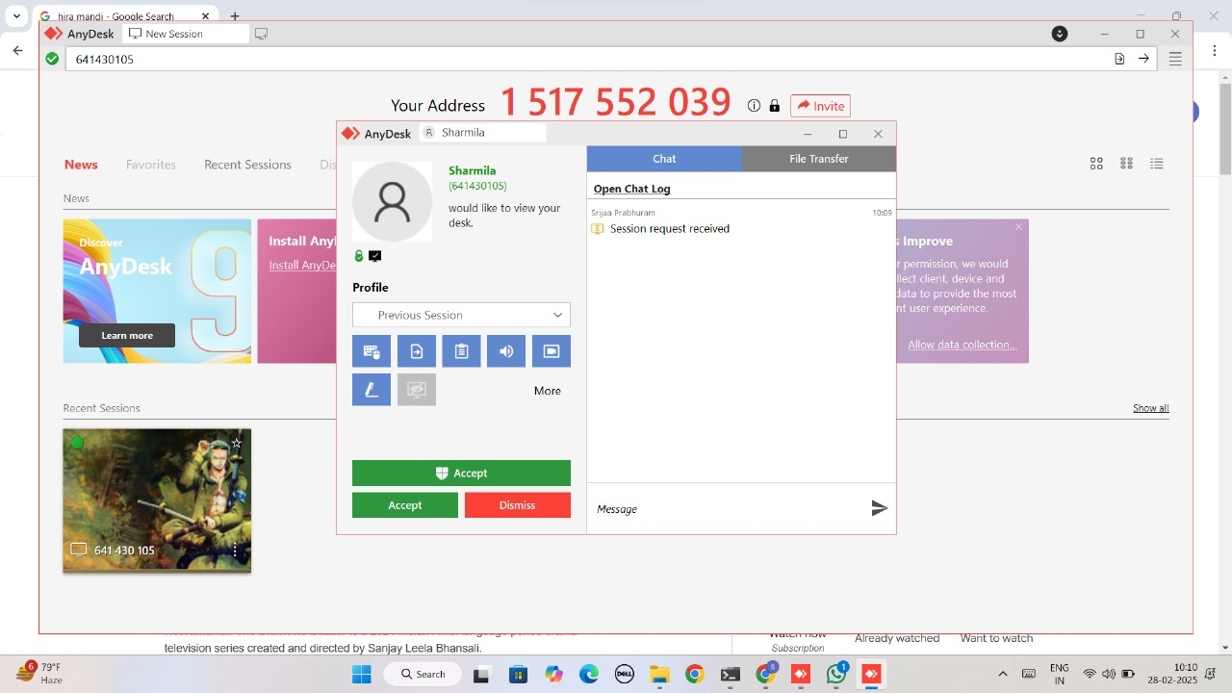

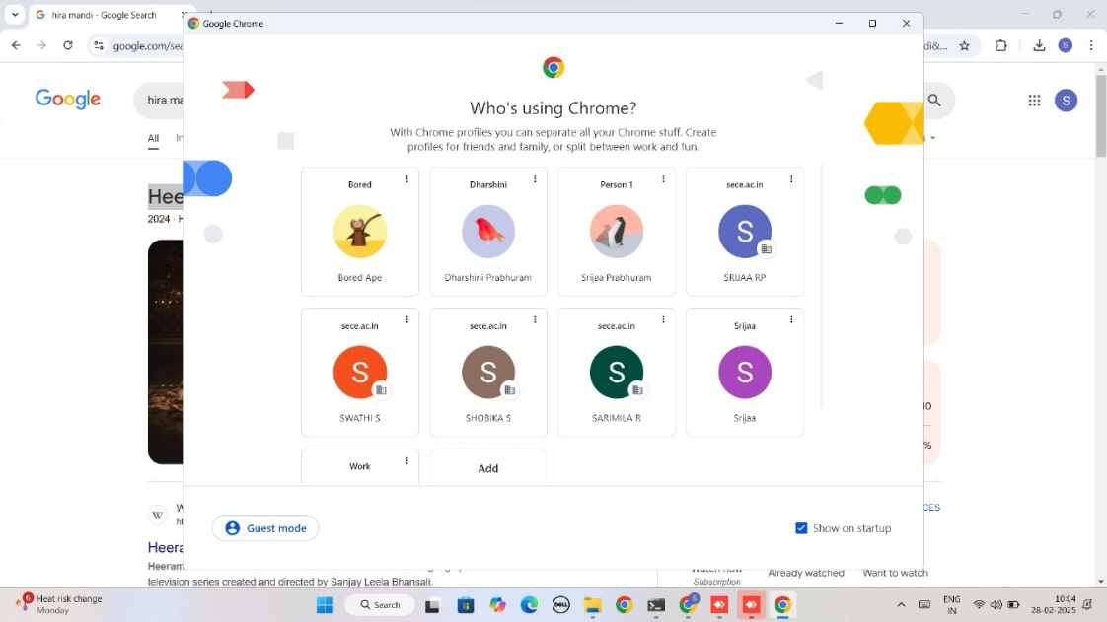

Using TeamViewer

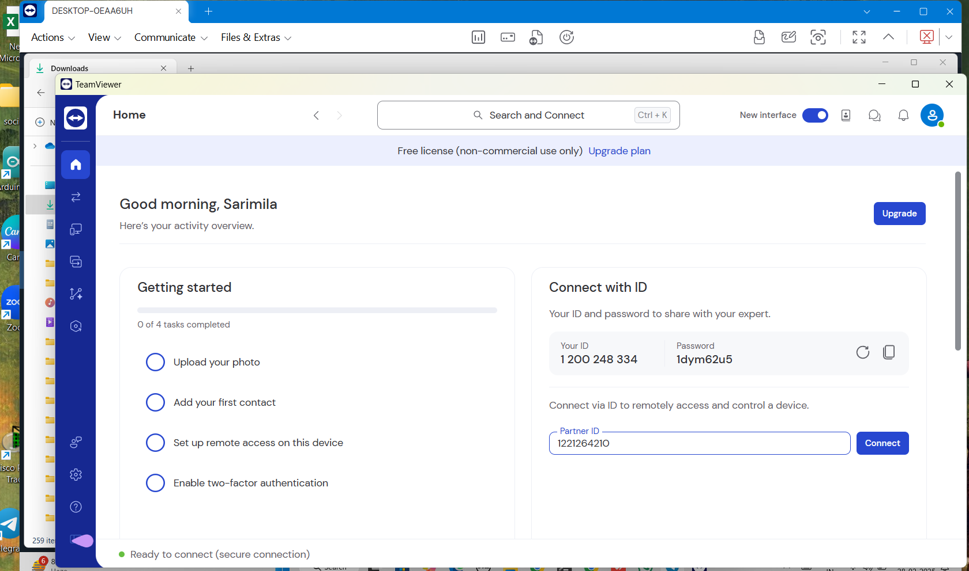

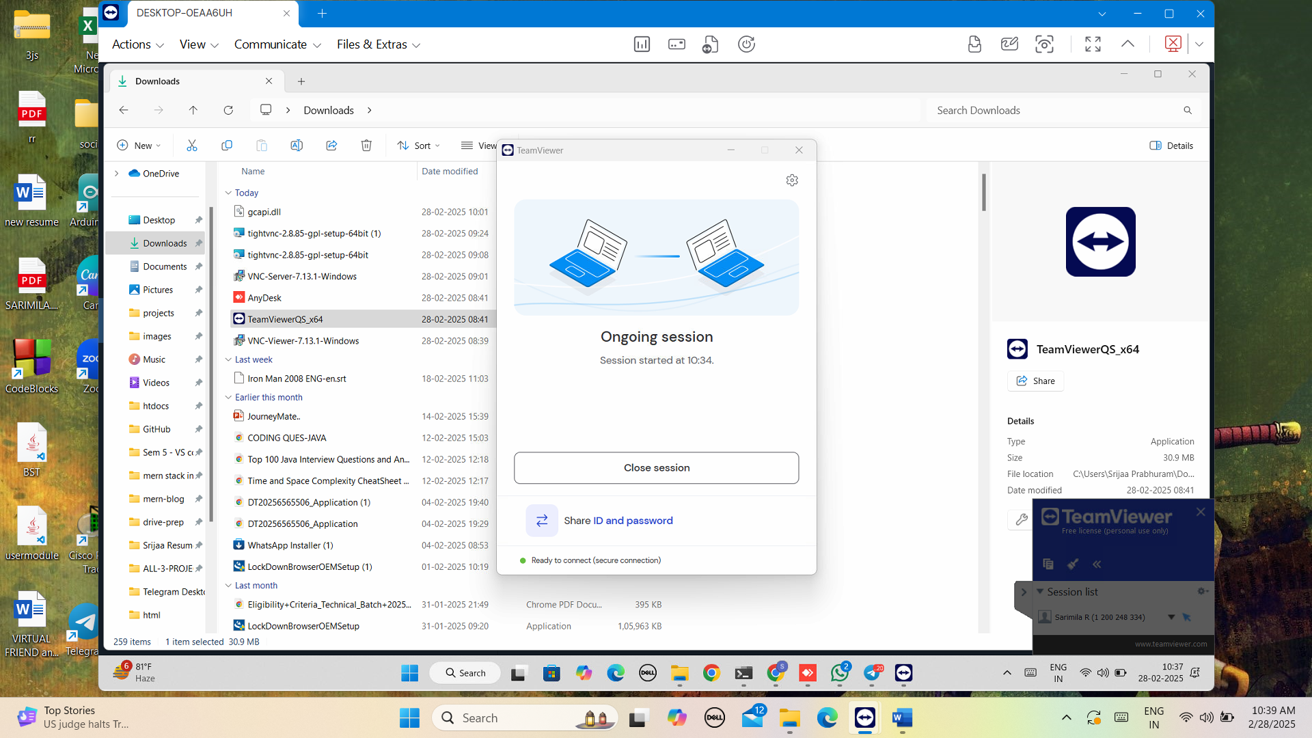

1. **How to check your default gateway is reachable or not and understand about default gateway.**

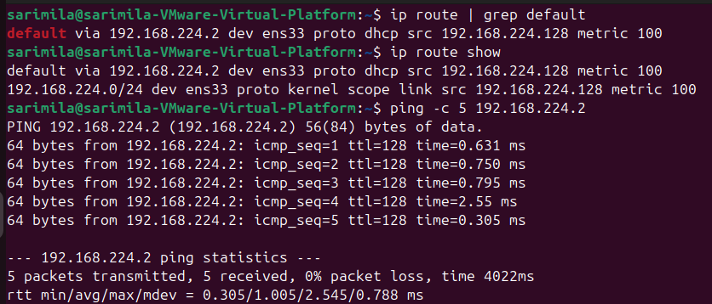

1. **Check iwconfig/ifconfig to understand in detail about network interfaces**

ifconfig is used to view and configure network interfaces.

iwconfig is used for wireless network configurations.

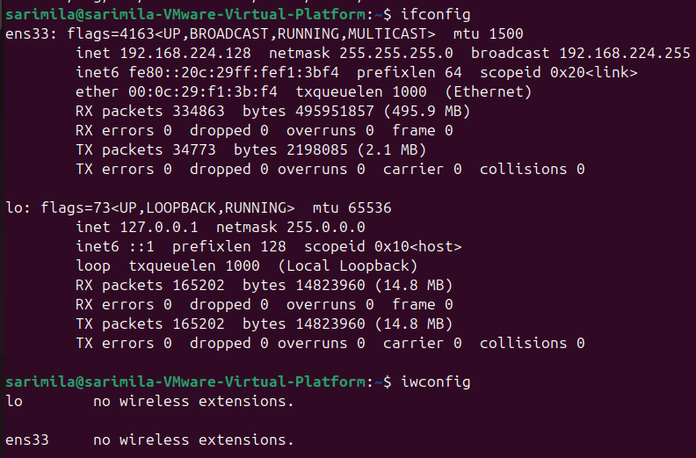

1. **Log in to your home router’s web interface (usually at 192.168.1.1 or 192.168.0.1) and check the connected devices list.**

I don’t have a home router. Steps to check connected devices:

ipconfig - Look for the Default Gateway

Enter the IP in the browser, login page will appear.  
Enter router username & password.

Here, all the list of connected devices with details will appear.

1. **Explain how a DHCP server assigns IP addresses to devices in your network.**

A DHCP server automatically assigns IP addresses to devices in a network, ensuring no conflicts. (DORA)

* Client Request (DHCP Discover)
* **S**erver Offers IP (DHCP Offer)
* Client Accepts (DHCP Request)
* Server Confirms (DHCP Acknowledgment)
* Renewal

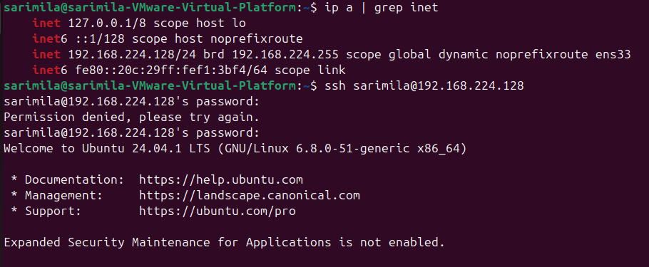**11. Using a terminal, connect to a remote machine via SSH and telnet.**